**Shahaan Mirza**

**Papademas**

**ITMD 411**

**Final Project Snapshots**

Program Description

This program acts as a ticket management system. Allowing users to open and close tickets which are stored in a MySQL Database. The database, along with Admin features, are accessible only to the administrators. The administrators can Update, Delete, and View tickets – in addition to Opening and Closing tickets. All users are allowed three login attempts before the application tells them to seek administrative help. The various submenu options provide an easy-to-understand GUI, and there is a check to ensure that the user wishes to continue with actions that are undoable, such as the deletion of a ticket. The framework of this application allows for the expansion and addition of new features as needed.

This application aims to provide a ready-to-implement solution to managing the various support tickets that an organization – in this case IIT – might be receiving. It is easy to see how long tickets have been open and whether or not they are closed to allow managers to prioritize troubleshooting certain applications.

GitHub Repository: [/shahaanmirza/ITMD411/](https://github.com/shahaanmirza/ITMD411/tree/main/FinalProject_smirza3)

userlist.csv

Admin – Username: admin, Password: password

Regular User – Username: Shahaan Mirza, Password: smirza3

**MySQL View**

Insert Ten Tickets

Update My Ticket (ID:1) Description

Delete My Ticket (ID:1)

Close Two Tickets

**GUI View**

Login Menu

Login Menu [Wrong Credentials]

Main Menu[Admin:True]

For Admin users, ALL submenu items are available to select from.

Main Menu [Admin:False]

For non-Admin users, there is no “Admin” menu item to select from.

Admin Submenu

These actions are only viewable by an administrative user.

Ticket Submenu

These actions are viewable by everyone.

Open A Ticket [1]

Open A Ticket [2]

Open A Ticket [3]

Update A Ticket [1]

Update A Ticket [2]

This GUI provides a drop down to allow the user to choose between updating the name or the description of a ticket.

Update A Ticket [3]

Update A Ticket [4]

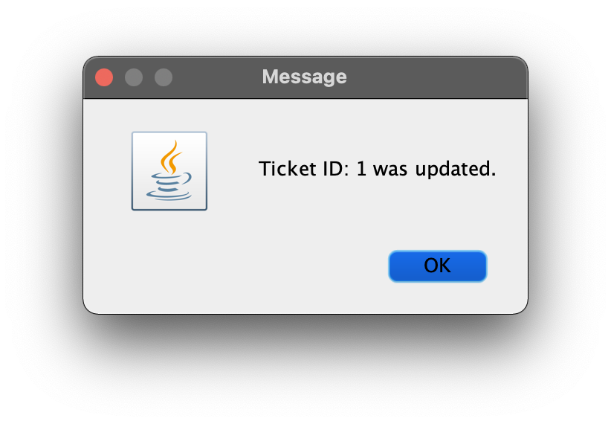

View Tickets

The GUI displays all ticket records in a table with the following columns (left to right):

Ticket ID, Ticket Issuer, Ticket Description, Ticket Start Date, Ticket End Date, Ticket Status [open/closed]

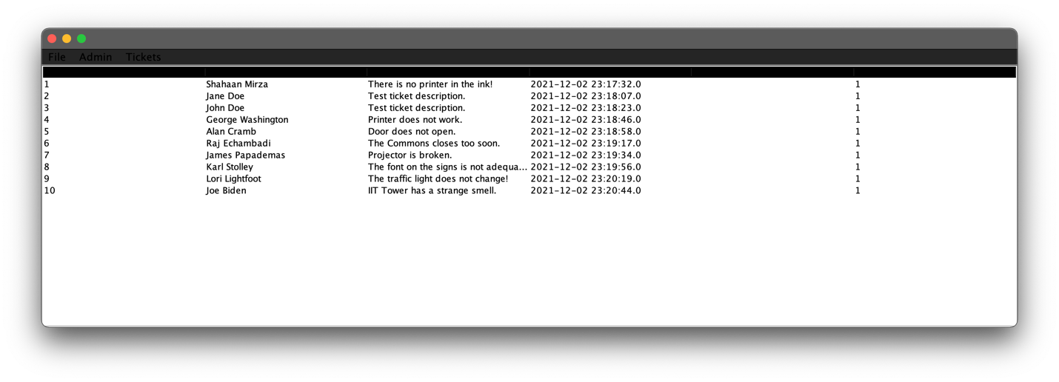

Delete A Ticket [1]

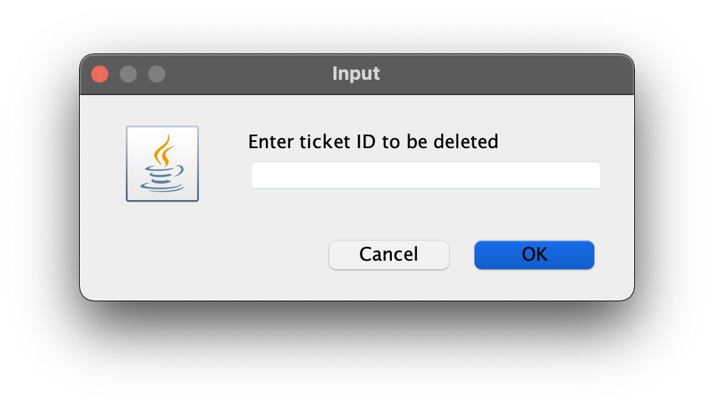

Delete A Ticket [2]

Application double checks with the user to verify whether or not the Ticket should be deleted from the SQL table.

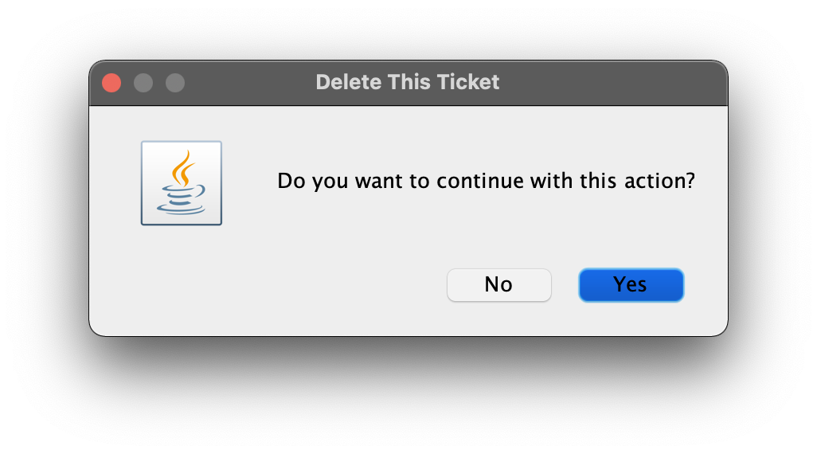

Delete A Ticket [3]

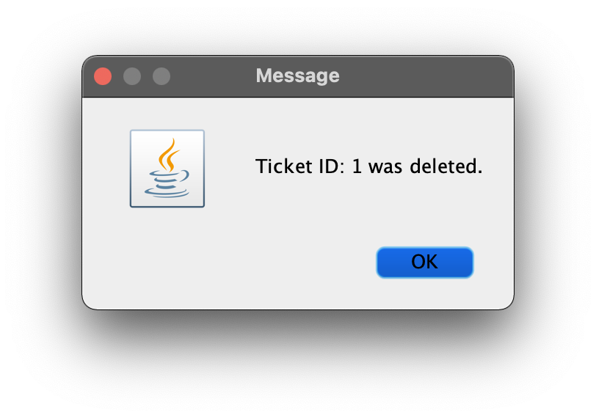

Close A Ticket [1]

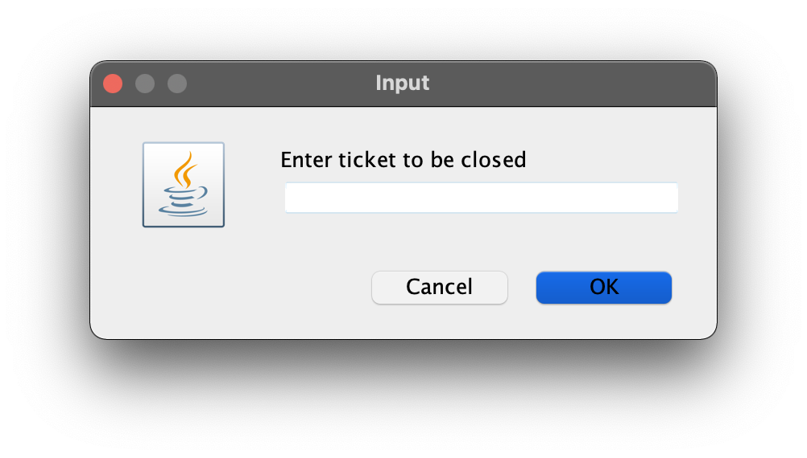

Close A Ticket [2]

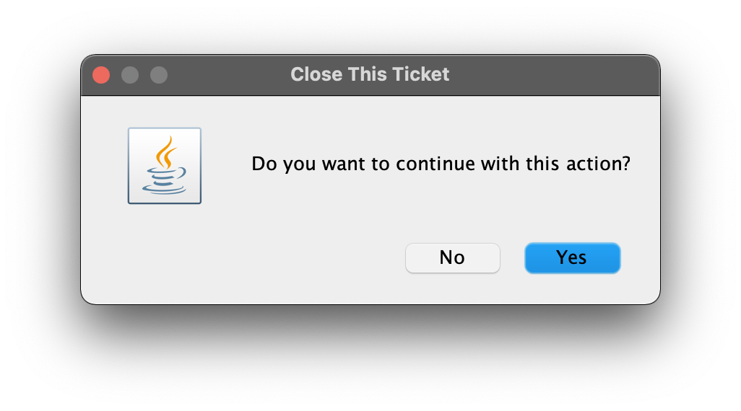

Close A Ticket [3]

